- INTRODUCTION
1.1 Introduction
In recent years, digital technology has significantly changed the education sector, especially the way examinations are conducted and managed. Many educational institutions are adopting online examination systems to make the examination process faster, easier, and more accessible. These systems allow students to attend examinations through digital platforms, while administrators and faculty members can manage examination schedules, question papers, student information, and results electronically.
Online examination systems provide several benefits, such as reduced paperwork, faster evaluation, easy access to examination information, and improved management. However, the increasing use of digital platforms has also created several security challenges. Important examination information must be protected from unauthorized access, data manipulation, question paper leakage, impersonation, and misuse of user privileges. These security issues can affect the fairness, confidentiality, and reliability of the examination process.
One of the major security concerns in digital examination systems is the insider threat. An insider threat occurs when a person who already has authorized access to a system misuses that access intentionally or unintentionally. Such individuals may include administrators, faculty members, employees, or other authorized users. For example, an authorized user may attempt to access confidential question papers, modify examination records, share sensitive information, or perform unusual activities beyond their normal responsibilities.
Traditional security mechanisms mainly depend on usernames, passwords, access permissions, and activity logs. Although these methods help protect systems from unauthorized external access, they may not be sufficient to identify suspicious activities performed by authorized users. Therefore, there is a need for an intelligent security framework that can continuously monitor user activities, identify unusual behaviour, and maintain secure records of important operations.
To address these challenges, this project proposes a Decentralized Blockchain and Agentic AI Framework for Proactive Insider Threat Detection in Examination Systems. The proposed framework combines Artificial Intelligence and Blockchain technology to improve examination security. Agentic AI is used to analyse user behaviour, identify unusual activities, and support early threat detection. Blockchain technology is used to maintain secure and tamper-resistant records of important examination-related activities.
By combining these technologies, the proposed system aims to provide better monitoring, transparency, accountability, and protection for digital examination environments.
1.2 Background of the Project
The development of online examination platforms has made it easier for educational institutions to conduct examinations without depending completely on traditional paper-based methods. Digital platforms help manage large amounts of examination information and allow users to perform different activities from a common system.
However, protecting examination information has become an important responsibility. Confidential data such as question papers, student details, examination schedules, and results must be handled carefully. If this information is accessed or modified by unauthorized individuals, it can create serious problems for educational institutions.
In many traditional systems, security is provided through centralized databases and role-based access control. These methods allow administrators to assign permissions to different users. Activity logs are also maintained to record important operations. However, these mechanisms generally focus on controlling access rather than understanding the behaviour of users after they enter the system.
For example, an administrator may have permission to access examination information for official purposes. However, if the same user accesses confidential information repeatedly or performs unusual operations, traditional systems may not immediately recognize the activity as suspicious.
Artificial Intelligence provides an opportunity to improve this situation by analysing user activities and identifying patterns that may indicate possible security risks. Blockchain technology provides another layer of protection by maintaining records in a decentralized and tamper-resistant manner.
The proposed project uses these technologies together to develop a more reliable examination security framework.
1.3 Need for the Project
The need for this project arises from the security limitations of existing digital examination systems. As educational institutions increasingly depend on online platforms, protecting confidential examination information has become more important.
One major problem is that authorized users can sometimes misuse their privileges. Traditional authentication methods cannot always identify such behaviour because the users may have valid login credentials. Therefore, simply checking usernames and passwords is not enough to ensure complete examination security.
Another important concern is the protection of stored information. Centralized databases may become vulnerable if the server is compromised or an individual gains unauthorized access. Any manipulation of important examination records can affect the accuracy and reliability of the system.
Manual monitoring is also a time-consuming process. Administrators may need to examine activity logs to identify unusual operations. When large numbers of users access the system, identifying suspicious behaviour manually becomes difficult.
Therefore, an intelligent framework is required to continuously analyse user behaviour, detect unusual activities, generate timely alerts, and maintain trustworthy records. The integration of Agentic AI and Blockchain technology can help address these challenges.
1.4 Role of Artificial Intelligence in Insider Threat Detection
Artificial Intelligence plays an important role in identifying unusual activities by analysing information collected from system users. Instead of depending only on predefined security rules, AI-based approaches can study user behaviour and identify patterns that may indicate possible threats.
In the proposed project, Agentic AI is used to support continuous monitoring and intelligent analysis of user activities. It can examine information such as login behaviour, access frequency, unusual data access, and activities performed by different user roles.
For example, if an authorized user accesses confidential examination information at an unusual time or performs activities that are different from their normal behaviour, the system can identify the activity as potentially suspicious.
The AI-based framework can analyse such activities, assess possible risks, and support the generation of security alerts. This helps administrators identify potential threats earlier and investigate them before they cause serious problems.
The use of Agentic AI makes the monitoring process more intelligent and helps reduce complete dependence on manual security checking.
1.5 Role of Blockchain Technology
Blockchain is a decentralized digital record-keeping technology that stores information in connected blocks. Each block contains data and a cryptographic link to the previous block. This structure makes unauthorized modification of recorded information difficult to perform without detection.
In the proposed examination security framework, Blockchain technology is used to maintain important activity records. Whenever a relevant examination-related operation takes place, its details or a suitable record reference can be stored in the blockchain-based system.
This helps create a transparent and verifiable record of important activities. Administrators can use these records to review previous operations and verify whether information has been modified.
The decentralized nature of Blockchain also reduces dependence on a single centralized record-keeping location. Smart contracts can be used to implement predefined rules for recording and verifying selected operations.
By using Blockchain technology, the proposed framework aims to improve data integrity, transparency, accountability, and trust in digital examination management.
- LITERATURE SURVEY
2.1 Introduction
The literature survey explains previous research and technologies related to insider threat detection, Artificial Intelligence, Blockchain, and online examination security. It helps us understand the methods already developed by researchers and identify the limitations of existing approaches.
Digital examination systems are becoming common in educational institutions. However, protecting examination information from unauthorized access, question paper leakage, data manipulation, and misuse of user privileges is a major challenge. Researchers have introduced different techniques to improve security, including Machine Learning, behavioural analysis, Blockchain, and smart contracts.
The following research papers provide useful information about these technologies and support the development of the proposed project.
2.2 Deltrux: Insider Threat Detection of End-User Behavior Analysis Using Machine Learning (2024)
This research paper presents a machine learning-based approach for identifying insider threats by analysing the behaviour of end users. Traditional security systems mainly depend on predefined rules and known threat patterns. However, these methods may fail to identify new or unusual activities performed by users.
The proposed Deltrux system studies different user activities, such as mouse movements, keystroke patterns, communication behaviour, operating system activities, and suspicious data operations. Machine Learning techniques are used to analyse these activities and identify differences between normal and unusual user behaviour.
When suspicious activities are detected, the system generates alerts through a centralized dashboard. This helps security teams monitor user activities and respond to possible threats.
The main advantage of this approach is that it focuses on user behaviour rather than depending only on login authentication. It can help identify suspicious activities at an early stage.
However, this research mainly focuses on end-user devices and enterprise environments. It does not specifically address examination-related security requirements or the use of Blockchain for maintaining secure examination activity records.
2.3 DTITD: An Intelligent Insider Threat Detection Framework Based on Digital Twin and Self-Attention Based Deep Learning Models (2023)
This research introduces an intelligent framework for detecting insider threats using Digital Twin technology and deep learning techniques. The main objective is to understand user behaviour and identify possible security risks through advanced data analysis.
The framework uses different deep learning models, including BERT, RoBERTa, and transformer-based approaches, to analyse user activities. It also studies the sequence and context of user behaviour to identify unusual patterns.
The researchers use the CERT insider threat datasets to evaluate their proposed detection methods. The framework focuses on improving the accuracy and speed of insider threat identification by combining behavioural analysis with deep learning models.
One important advantage of this research is its ability to analyse complex user behaviour and identify suspicious patterns that may not be detected through traditional security methods.
However, the framework involves complex deep learning techniques and is mainly designed for organizational security environments. It does not specifically focus on online examination systems or decentralized Blockchain-based activity records.
2.4 An Advanced and Secure Framework for Conducting Online Examination Using Blockchain Method (2023)
This research paper, written by Md. Rahat Ibne Sattar and other researchers, proposes a Blockchain-based framework for improving the security of online examination systems.
The paper explains that traditional online examination platforms mainly depend on user IDs and passwords. These methods may be affected by password misuse, unauthorized access, and examination-related security problems.
To overcome these issues, the researchers introduce Blockchain technology to improve the security of examination information. The framework supports secure data management and helps maintain examination records without depending completely on copies stored in centralized servers.
Blockchain provides a decentralized and tamper-resistant method of maintaining important information. It also helps improve the security of question paper delivery and examination evaluation.
The main advantage of this approach is that it improves data integrity, transparency, and trust in online examination systems.
However, the research mainly concentrates on Blockchain-based examination security. It does not provide a complete Agentic AI-based approach for continuously analysing user behaviour and predicting possible insider threats.
2.5 ExamGuard: Smart Contracts for Secure Online Test (2025)
This research paper presents ExamGuard, a framework that uses Blockchain smart contracts and Artificial Intelligence techniques to improve online examination security.
The system uses smart contracts to maintain examination-related information and provide traceability of evaluation data and student activities. It also uses the PoseNet algorithm to identify and monitor the faces and movements of examinees during online examinations.
The COCO dataset is used for object recognition in the examination environment. This helps identify objects and activities that may affect examination integrity. Blockchain technology is used to securely maintain examination evidence and records.
The main advantage of this research is the combination of AI-based examination monitoring and Blockchain technology. It improves examination transparency and helps maintain secure records of examination activities.
However, the main focus of this framework is monitoring examinees during examinations. It does not specifically concentrate on detecting insider threats caused by authorized administrators, faculty members, or other privileged users.
2.6 Research Gap
From the above research papers, it can be understood that different technologies have been developed to improve security in digital environments.
Deltrux focuses on identifying insider threats through machine learning and user behaviour analysis. DTITD uses Digital Twin technology and deep learning models for intelligent threat detection. The Blockchain-based examination framework focuses on protecting examination information and maintaining secure records. ExamGuard combines smart contracts and AI-based monitoring to improve online examination security.
Although these approaches provide useful security features, they mainly address individual aspects of the problem. There is a need for a combined framework that can analyse the behaviour of authorized users, identify possible insider threats, generate timely alerts, and maintain secure records of important examination activities.
Therefore, the proposed project combines Agentic Artificial Intelligence and Blockchain technology to address these requirements in a single examination security framework.

- EXISTING SYSTEM

3.1 Overview of the Existing System
The existing examination management system uses traditional security methods to manage and protect examination-related information. These systems are generally based on centralized databases, user authentication, access control, and activity logs.
Users such as students, faculty members, and administrators access the platform using their registered usernames and passwords. Based on their roles, different permissions are provided. Students can view examination details, faculty members can manage academic activities, and administrators can control examination operations.
The system stores important information such as student details, examination schedules, question papers, and results in a centralized database. Activity logs are also maintained to record important user operations.
Although these methods provide basic security, they mainly focus on controlling system access. They may not effectively identify suspicious activities performed by authorized users. This creates a possibility of insider threats, where users misuse their permissions to access or modify confidential information.

3.2 Working Process of the Existing System
The traditional examination system follows a process that includes user login, authentication, role-based access, examination management, centralized data storage, and activity monitoring.
Initially, users enter their registered login credentials. The system verifies the username and password with the stored information. If the details are correct, access is granted; otherwise, access is denied.
After successful login, users can access features according to their assigned roles. Students can view examination information, faculty members can manage academic activities, and administrators can manage examination-related operations.
All important information is stored in a centralized database. Whenever users perform activities, the system records relevant details in activity logs. Administrators can review these records to identify reported security problems.
However, this process mainly depends on predefined rules and manual monitoring. If an authorized user performs unusual activities, the system may not immediately recognize them as suspicious.

3.3 Security Mechanisms Used in the Existing System
Traditional examination systems use the following security mechanisms:
1. User Authentication: Users must enter a valid username and password before accessing the system. This helps prevent unauthorized login attempts.
2. Role-Based Access Control: Different permissions are provided according to user roles. Students, faculty members, and administrators have access to different system features.
3. Centralized Database Management: Examination information, including student details, question papers, schedules, and results, is stored in a central database for easy management.
4. Activity Logging: Important user operations are recorded in logs. Administrators can review these records whenever security issues occur.
5. Basic Security Monitoring: The system monitors certain activities, such as failed login attempts and unauthorized access. However, it may not identify complex suspicious behaviour performed by authorized users.

3.4 Limitations of the Existing System
Although traditional examination systems provide basic protection, they have several limitations.
1. Lack of Proactive Threat Detection: Traditional systems may identify security problems only after suspicious activities occur. They do not continuously analyse user behaviour to identify possible insider threats early.
2. Centralized Data Storage: Storing all information in one central database creates a single point of failure. If the server is compromised, confidential examination information may become vulnerable.
3. Limited Behavioural Analysis: Traditional systems mainly verify login credentials and user permissions. They do not continuously study user activities to identify unusual behaviour.
4. Risk of Data Manipulation: Users with sufficient permissions may modify examination records or confidential information. Detecting such changes can be difficult.
5. Misuse of Administrator Privileges: Authorized administrators or faculty members may misuse their access privileges to view or modify sensitive examination information.
6. Delayed Security Alerts: Manual monitoring of activity logs can take time. As a result, suspicious activities may not be identified immediately.
7. Lack of Tamper-Resistant Records: Centralized activity logs may be vulnerable if the storage system is compromised. This can make it difficult to verify the accuracy of previous activities.

3.5 Problems Faced in the Existing System
The limitations of traditional examination systems create several problems for educational institutions. Question paper leakage, unauthorized access, and modification of examination records can affect the fairness and reliability of examinations.
Students may lose confidence in the examination process if confidential information is exposed. Faculty members and administrators may also face difficulties in protecting academic data.
Another major problem is the dependence on manual monitoring. Administrators must examine large amounts of activity information to identify suspicious operations. This can delay the investigation of security incidents.
Therefore, an improved security framework is required to continuously monitor user activities, identify unusual behaviour, generate timely alerts, and maintain reliable records of important operations.

3.6 Summary
The existing examination system provides basic security through user authentication, role-based access control, centralized databases, and activity logging. These methods help manage examination information and restrict unauthorized access.
However, traditional systems have limitations in detecting insider threats, analysing user behaviour, preventing data manipulation, and generating immediate security alerts.
To overcome these limitations, the proposed project combines Agentic Artificial Intelligence and Blockchain technology. This approach aims to improve examination security through intelligent activity monitoring, early threat detection, and secure record management.

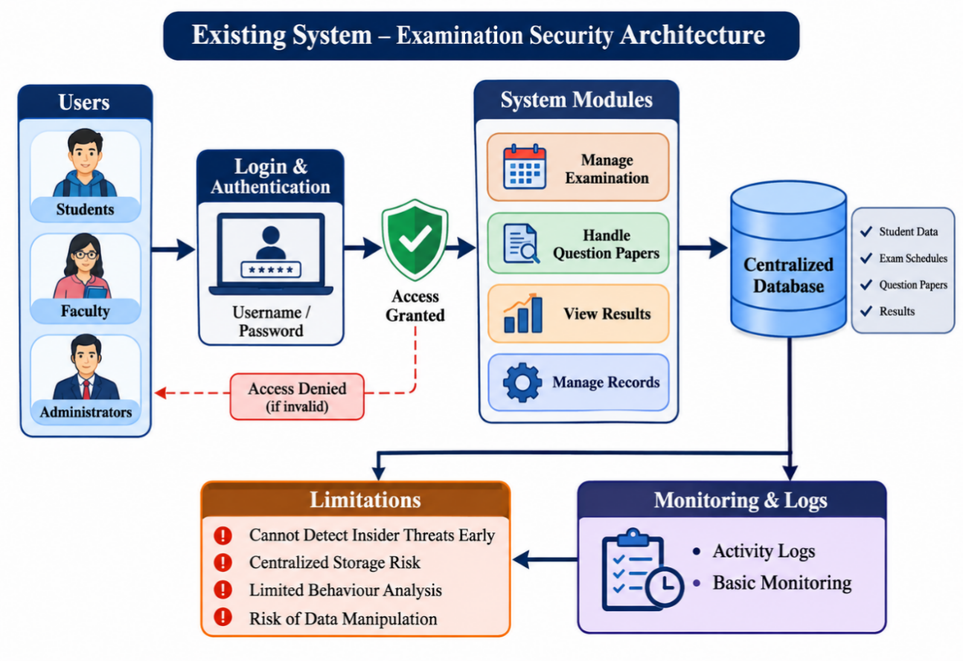

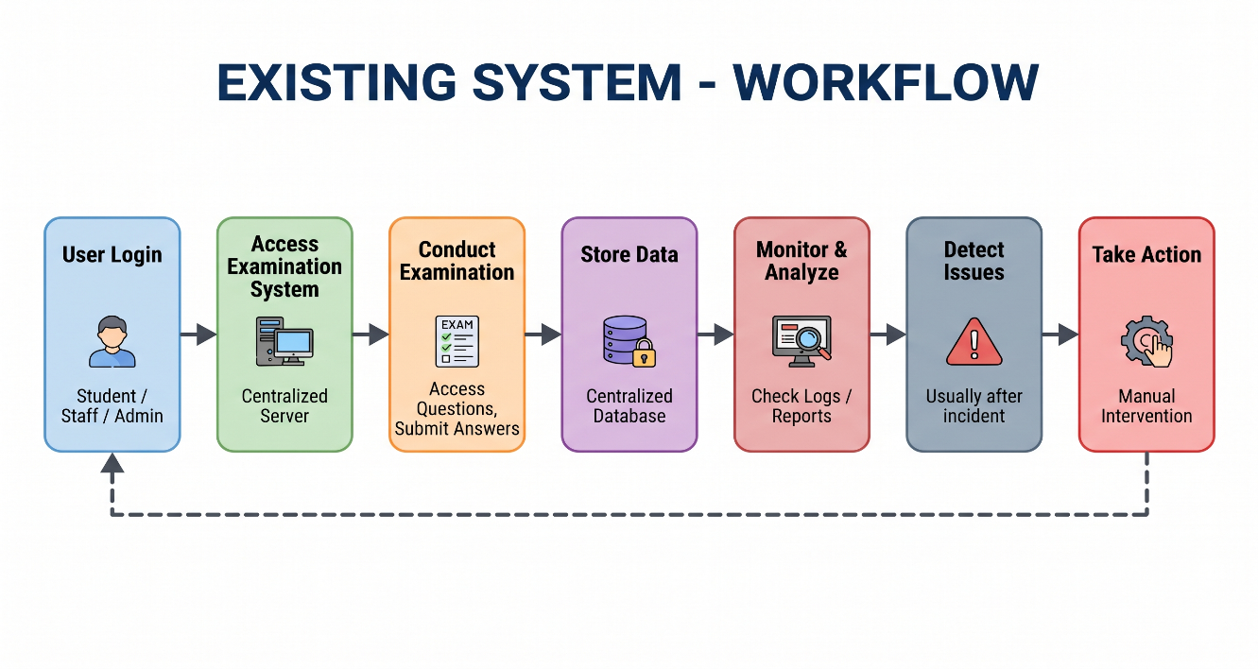

- PROPOSED SYSTEM
4.1 Overview of the Proposed System
To overcome the critical vulnerabilities of conventional centralized examination setups, this project presents a Decentralized Blockchain and Agentic AI Framework for Proactive Insider Threat Detection in Examination Systems. Standard examination portals depend entirely on static log files, passive database triggers, and retrospective manual audits. Such mechanisms invariably fail when privileged insiders—such as database administrators, technical assistants, evaluation coordinators, or invigilators—deliberately abuse their authorized permissions to leak examination papers, alter records, or wipe digital footprints.
The proposed architecture establishes a proactive, intelligent defence paradigm by coupling Agentic AI with Decentralized Blockchain Technology. Instead of responding only after a data compromise has occurred, autonomous AI agents operate across the environment to track live interaction streams, establish behavioural baselines, identify anomalous deviations, and predict unauthorized insider threats before any destructive impact happens. Simultaneously, every sensitive operation, authentication credential verification, transaction timestamp, and generated alert is committed into a tamper-resistant, distributed blockchain ledger. This design eliminates single points of failure, guarantees complete transparency, and provides mathematically provable non-repudiation across the entire academic assessment lifecycle.
4.2 Key System Modules
- User Authentication & Role-Based Access Control (RBAC): Manages identity validation across students, faculty, and system administrators with granular, time-bound session tokens to restrict access exclusively to authorized operations.
- Continuous Activity Monitoring Engine: Collects event telemetry across all application layers—including session durations, keystroke dynamics, question retrieval timestamps, download volumes, and record alteration requests.
- Agentic AI Behavioural Analytics & Prediction Module: Autonomous software agents construct baseline profiles of standard behavioural norms and utilize predictive models to detect abnormal operational deviations in real time.
- Decentralized Blockchain Logging Ledger: Critical operations (e.g., question bank uploads, paper decrypts, grading modifications, access failures) are hashed and committed to an immutable ledger via smart contracts, preventing log alterations by internal staff.
- Real-Time Alert & Automated Notification System: Automatically pushes urgent visual warnings and actionable risk notifications to supervisory dashboards upon identifying high-risk anomaly scores.
- Administrative Action & Continuous Feedback Loop: Enables designated controllers to review flagged operations, freeze compromised sessions, and feed false-positive/confirmed-threat data back into the AI agent to continuously refine prediction baselines.
4.3 Step-by-Step Workflow Execution
- Secure Login & Authentication: Every participant (student, faculty, exam administrator) undergoes multi-factor authentication. The platform assigns least-privilege role permissions, establishing a cryptographically verified session environment.
- Activity Monitoring & Telemetry Collection: During the active examination cycle, background monitor services gather live operational telemetry. This includes navigation patterns, API request rates, bulk file access attempts, and out-of-schedule administrative queries targeting sensitive tables.
- Behavioural Inference & Agentic Reasoning: The streaming telemetry passes directly into the Agentic AI layer. Rather than depending solely on static if-then rules, autonomous agents evaluate contextual variables—such as whether a staff member accessed a question repository outside working hours or queried unauthorized student answer sheets.
- Cryptographic Ledger Commitment: Key state changes and access events are converted into cryptographic hashes and added as new blocks within the distributed blockchain network. Smart contracts prevent unauthorized revisions, log purges, or selective history deletion.
- Risk Scoring & Real-Time Alert Generation: When an action breaches the threat probability threshold, the AI agent generates a structured alert containing the user identity, targeted resource, confidence score, and contextual anomaly explanation.
- Administrative Response & Verification: Supervisory administrators review alerts against the immutable blockchain history. They can immediately terminate active sessions or lock credentials, ensuring rapid containment and auditable evidence for forensic accountability.
4.4 Agentic AI Behavioural Profiling Architecture
- Autonomous Goal-Oriented Monitoring: Agents independently formulate surveillance goals, assess anomalous paths, and cross-reference user actions against historical norms.
- Multi-Dimensional Anomaly Scoring: Evaluates access timings, network locations, resource sensitivity, and payload volumes to calculate composite threat indexes.
- Predictive Threat Prevention: Proactively predicts privilege escalation or data leakage risks before question papers or grades are permanently exfiltrated.
- Self-Tuning Baselines: The agent continuously updates role-based behavioural thresholds via post-incident feedback, reducing false positives over time.
4.5 Decentralized Blockchain Security Framework
- Non-Repudiation of Privileged Actions: Every privileged action—such as releasing an exam key, altering an answer sheet, or updating master configurations—requires a digital signature that is committed to the blockchain, preventing staff from denying unauthorized changes.
- Tamper-Resistant Audit Logging: Log entries are distributed across decentralized network nodes, rendering local log deletion or database tampering impossible even for internal root administrators.
- Smart Contract Policy Enforcement: Pre-programmed rules dictate that critical datasets, such as final exam papers, remain locked and unviewable until a decentralized consensus condition (e.g., specific date, time, and multi-signature authorization) is satisfied.
4.6 Comparative Analysis
Evaluation Metric | Conventional Examination System | Proposed Agentic AI + Blockchain System
Architectural Model | Centralized server and database | Hybrid decentralized ledger with intelligent agent layer
Threat Detection Approach | Reactive (post-incident forensic review) | Proactive (predictive real-time behavioural monitoring)
Log Integrity | Susceptible to privileged insider modification/deletion | Cryptographically immutable and tamper-proof
Insider Threat Mitigation | Minimal (vulnerable to credential misuse) | Robust (autonomous agents track privilege deviations)
Audit Transparency | Opaque; restricted to internal system admins | Transparent, verifiable, and non-repudiable audit trails
4.7 Key Advantages & Institutional Impact
- Elimination of Single Points of Failure: Decentralized data verification prevents single-server compromises from shutting down the entire examination process.
- Early Detection of Insider Threats: Autonomous behavioural analysis identifies and flags unauthorized data queries before leaks occur.
- Guaranteed Audit Accountability: Immutable blockchain logging ensures indisputable evidence for institutional investigations and compliance audits.
- Enhanced Academic Integrity: Protects institutional credibility by providing students, educators, and administrators with an unbiased, fair, and reliable testing platform.

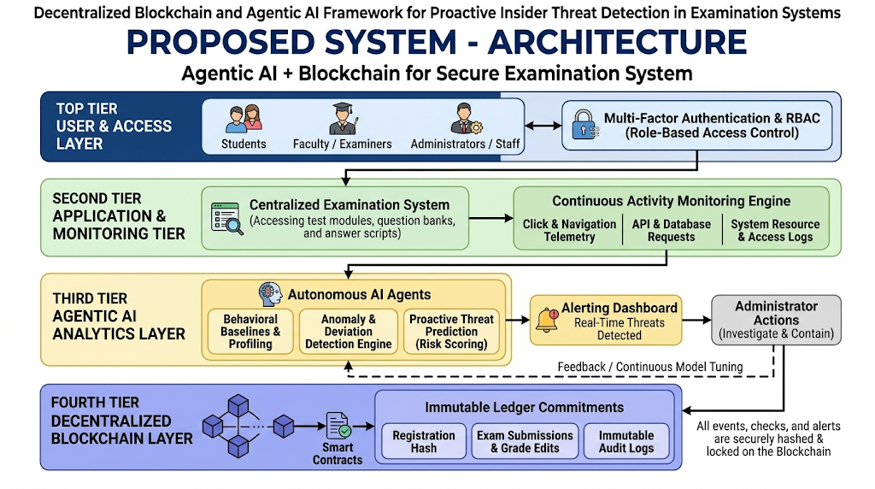

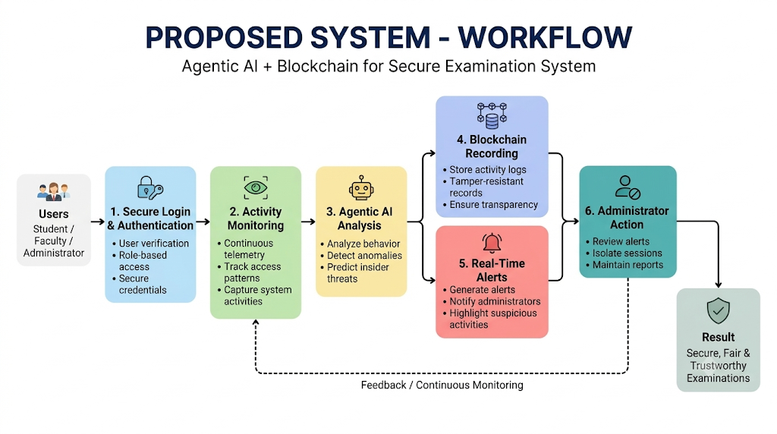

- SYSTEM ARCHITECTURE
5.1 Introduction & Layered Overview
To resolve systemic vulnerabilities and eliminate privileged insider manipulation, the proposed Decentralized Blockchain and Agentic AI framework is designed as a secure, multi-tier distributed architecture. Unlike traditional single-server setups that rely on easily erasable local logs and post-incident forensic reviews, this tiered architecture embeds continuous behavioural inference directly alongside decentralized immutable ledgers.
The architecture comprises four core interdependent layers:
- Top Tier: User & Access Layer (Authentication & RBAC)
- Second Tier: Application & Continuous Monitoring Tier
- Third Tier: Agentic AI Analytics Layer
- Fourth Tier: Decentralized Blockchain Layer

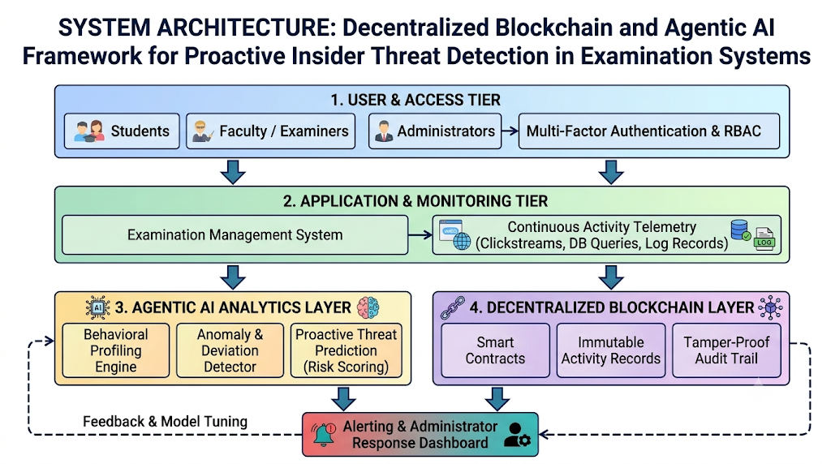

5.2 Top Tier: User & Access Layer
This entry-point tier acts as the primary boundary control layer. Rather than allowing unfiltered access, it subjects all incoming participants—Students, Faculty/Examiners, and Admin staff—to rigorous Multi-Factor Authentication (MFA) and granular Role-Based Access Control (RBAC). It prevents credential cloning, enforces least-privilege policies, and generates cryptographically verifiable user session tokens. No operation can proceed without verified, time-bound identity validation.
5.3 Second Tier: Application & Monitoring Tier
This tier forms the operational backend, linking exam candidates and staff to essential assessment workflows. It supports the active Centralized Examination System (managing question bank ingestion, module testing, and exam submissions).
A key focus of this tier is the Continuous Activity Monitoring Engine. Unlike standard servers that only record simple server events, this engine captures live activity telemetry. It tracks:
- User & Navigation Telemetry: Real-time clickstreams, interaction velocities, dwell times, and page transition patterns.
- API & Database Queries: Request rates, payload parameters, unauthorized data read/write attempts, and sensitive schema lookups.
- System Resource Logs: Inbound IP traces, concurrent session tokens, out-of-schedule administrative queries, and bulk file downloads.
By gathering these continuous data points, it creates a complete audit trail, providing the baseline activity data needed for behavioural analysis.
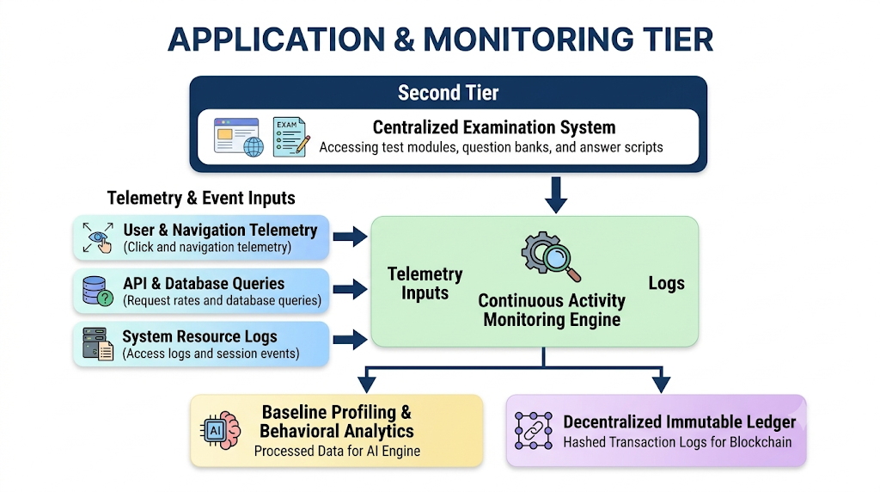

5.4 Third Tier: Agentic AI Analytics Layer
This intelligence layer analyzes behavior and predicts security threats. Traditional filters can only alert on known signatures. This layer uses Agentic AI to assess context and intent by analyzing telemetry stream deviations.
It features three core modules:
- Behavioral Baselines & Profiling: Profiles typical user routines, such as data download caps, working hours, access frequencies, and expected administrative paths.
- Anomaly & Deviation Detection Engine: Flags real-time variations in user behavior, such as bulk data exports, access from unusual geographical locations, or exam table modifications outside examination windows.
- Proactive Threat Prediction (Risk Scoring): Evaluates composite risk metrics across multiple operational factors to compute a predictive threat index, isolating insider risks before actual breaches occur.
High-risk activity sends warnings to the Alerting Dashboard ("Real-Time Threats Detected") for administrators to freeze suspect sessions or halt data. It incorporates continuous Feedback & Model Tuning from responses to enhance identification accuracy and minimize false alarms.

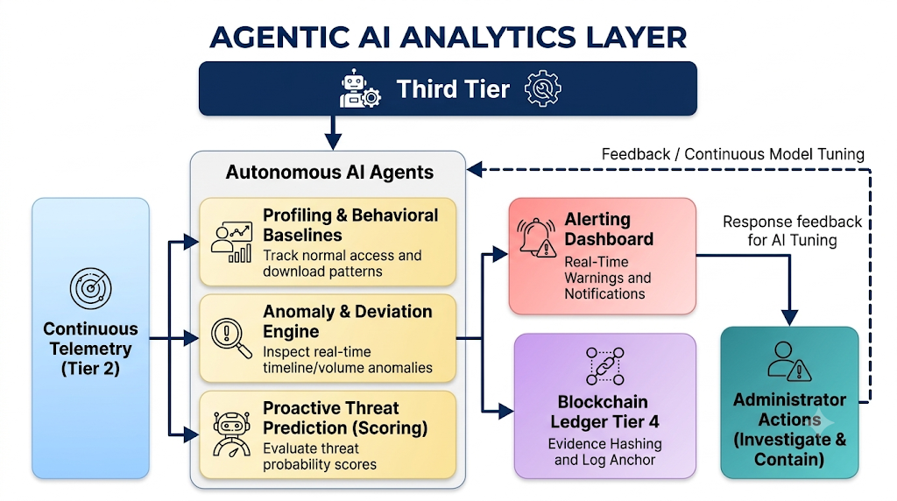

5.5 Fourth Tier: Decentralized Blockchain Layer
This tier ensures audit trail immutability across the examination lifecycle. Actions such as student registrations, question releases, configuration updates, and grade submissions are hashed and recorded via Smart Contracts, establishing a tamper-proof log.
Smart Contracts enforce data security protocols:
- Validation Hashes: Verify genuine user interactions and question bank authenticity.
- Key Event Histories: Lock test releases, score uploads, and permission modifications into unalterable blocks.
- Immutable Audit Trails: Maintain chronological operational logs across decentralized validator nodes, preventing retroactive tampering even by root-level database administrators.
5.6 Interaction & Multi-Tier Workflow
Data flows through specific verification paths:
- Entry-Point Verification: Manages user credentials, authentication tokens, and access roles (Tier 1).
- Operational Telemetry: Generates continuous process traces during examination tasks (Tier 2).
- Behavioral Analysis: Autonomous AI agents inspect interaction streams, flag anomalies, and assign threat scores (Tier 3).
- Security Logging: Cryptographically anchors state transitions, access histories, and security alerts to the ledger (Tier 4).

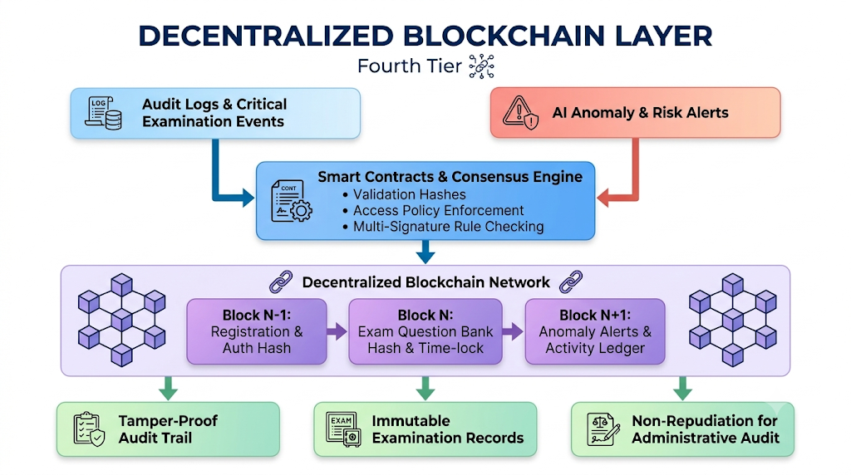
- MODULES

6.1 MODULE 1: SECURE AUTHENTICATION & ACTIVITY MONITORING

This module acts as the access gate and live activity logger for the examination platform. It checks user credentials using Multi-Factor Authentication (MFA) and grants access based on roles—Student, Faculty, or Admin. At the same time, background listeners continuously record user actions, such as mouse movements, keystrokes, question view times, and system queries.

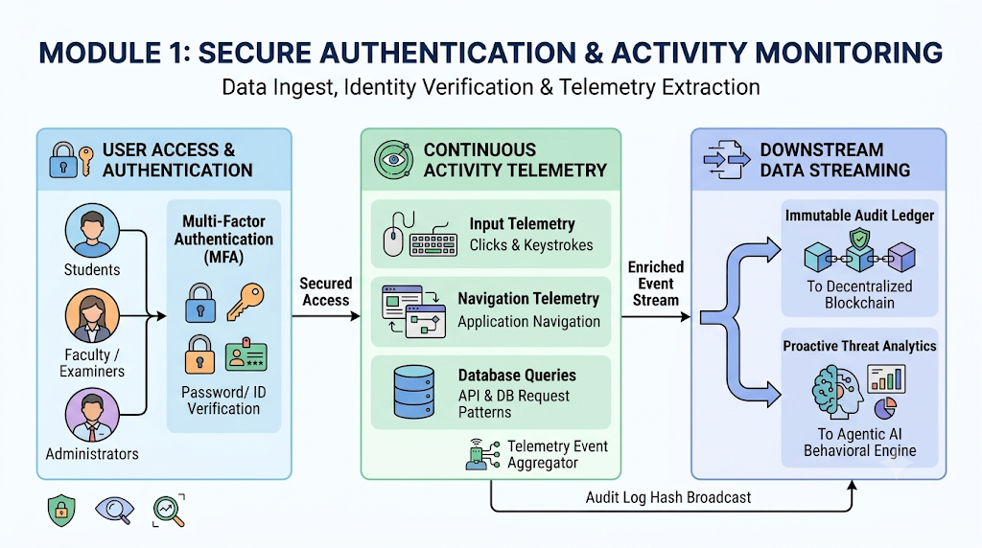

- Role-Based Access Control (RBAC): Restricts each user strictly to authorized exam functions.
- Continuous Behavioral Telemetry: Records navigation flow, interaction speed, and question view times.
- Query & Event Logging: Captures unusual access times, API call spikes, and database requests.

6.2 MODULE 2: AGENTIC AI BEHAVIORAL ANALYTICS & THREAT PREDICTION

This module acts as the smart monitoring brain that identifies potential insider threats early. Autonomous AI agents learn normal user patterns to build baseline behavior profiles. When abnormal actions occur—such as bulk exam paper downloads or late-night administrative logins—the AI evaluates the deviation and generates a threat probability score before any leak occurs.

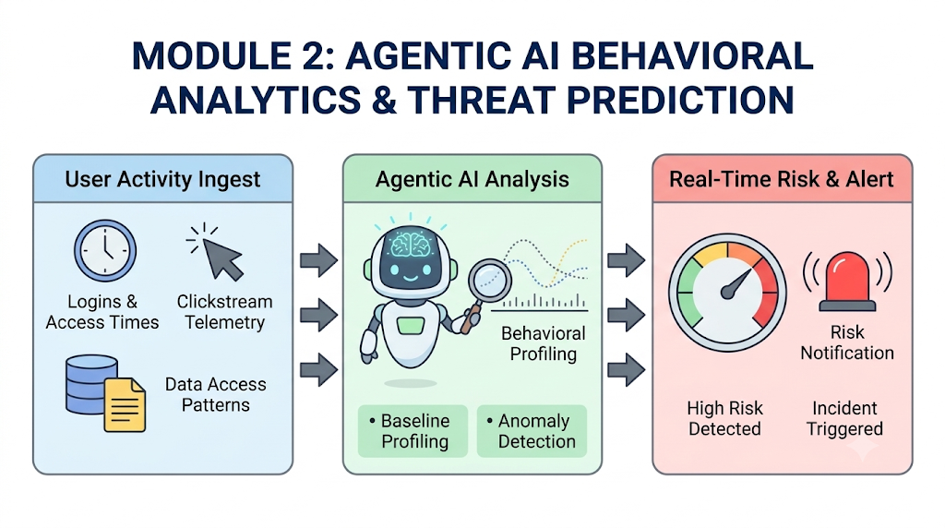

Behavioral Profiling: Learns standard activity routines, access hours, and query volumes for each role.
Anomaly Detection: Flags sudden deviations, like unexpected exports or strange login hours.
Proactive Risk Scoring: Computes a risk level to detect insider threats before damage happens.

6.3 MODULE 3: DECENTRALIZED BLOCKCHAIN LOGGING & SMART CONTRACTS

This module provides an immutable, decentralized ledger to record vital examination actions. Sensitive events—such as student logins, question uploads, paper decryptions, and grade edits—are hashed using cryptographic algorithms and added to the blockchain. Smart contracts enforce policies automatically, keeping question papers locked until the exam start time and preventing administrators from deleting records.

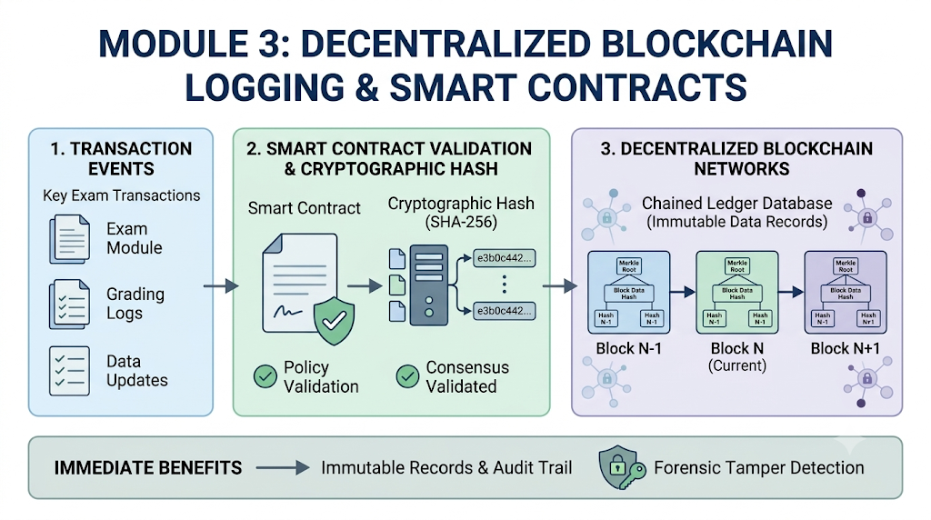
Cryptographic Event Hashing: Encrypts examination transactions and AI alerts into tamper-proof records.
Smart Contract Policy Enforcement: Unlocks question papers only when multi-signature rules and scheduled times are met.
Immutable Audit Trail: Prevents any internal user or administrator from tampering with or erasing logs

6.4 MODULE 4: REAL-TIME ALERTS & ADMINISTRATIVE INCIDENT CONTAINMENT

This module functions as the security dashboard for examination supervisors. When the AI detects high-risk behavior, the module sends immediate alerts detailing the user ID, anomaly type, and the corresponding blockchain record hash. Administrators can inspect the alert, freeze suspicious sessions, revoke access tokens, and send resolution feedback back to the AI model.

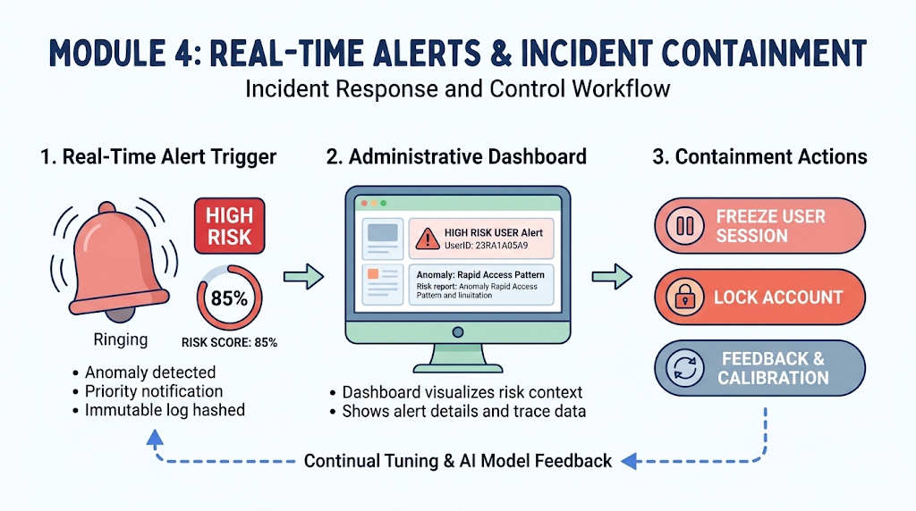
- Priority Alert Dispatcher: Shows instant visual alerts based on threat severity scores.
- One-Click Session Containment: Enables administrators to immediately lock suspect accounts and revoke tokens.
- Continuous Feedback Loop: Sends threat outcomes back to fine-tune the AI detection model.

- UML DIAGRAMS
Explanation & Overview
The Use Case Diagram defines the interactions between the external actors (Students, Faculty/Examiners, System Administrators) and the core internal subsystems (User Authentication, Continuous Telemetry Monitoring, Agentic AI Analytics, and the Decentralized Blockchain Ledger). It outlines how each role accesses specific functionalities within the secure examination framework.
Primary Actors & Roles:
- Student: Authenticates via MFA, views exam schedules, accesses active question modules, and submits digital answer scripts.
- Faculty / Examiner: Ingests question banks, manages assessment timelines, and reviews examination analytics.
- System Administrator: Oversees the integrity dashboard, configures security policies, and executes incident containment actions.
- Agentic AI Engine: Operates as an automated system actor that ingests live telemetry, computes behavioral anomaly scores, and triggers real-time alerts.
- Blockchain Ledger: Acts as the immutable storage actor that validates smart contracts, logs cryptographic transaction hashes, and enforces time-lock policies

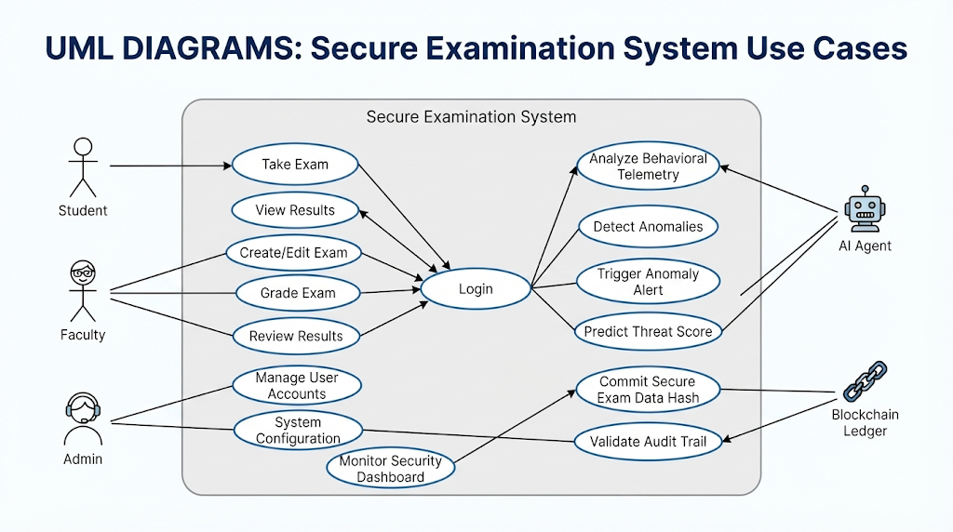

CLASS DIAGRAM
Explanation & Overview

The Class Diagram models the static structural backbone of the application. It defines the core domain classes, their attributes, operations, and structural relationships (such as associations, composition, and inheritance) that govern data flow across the system modules.
- User: Manages actor properties (userID, role, email) and methods (login(), logout(), viewProfile()).
- Authentication: Handles session validation (sessionToken, mfaStatus, jwtExpires) and security verification (validateCredentials(), enforceMFA()).
- TelemetryEngine: Ingests raw interaction streams (engineID, activeListeners) and normalizes event data (ingestTelemetry(), normalizeData()).
- AgenticAI: Performs behavioral analysis (agentID, riskThreshold) and threat predictions (detectAnomaly(), predictThreat()).
- BlockchainLedger: Anchors unalterable records (ledgerID, consensusMechanism) and validates state integrity (recordTransaction(), validateChainIntegrity()).
- AdminDashboard: Visualizes real-time metrics (dashboardID, activeAlerts) and executes responses (investigateUser(), triggerIncidentResponse()).

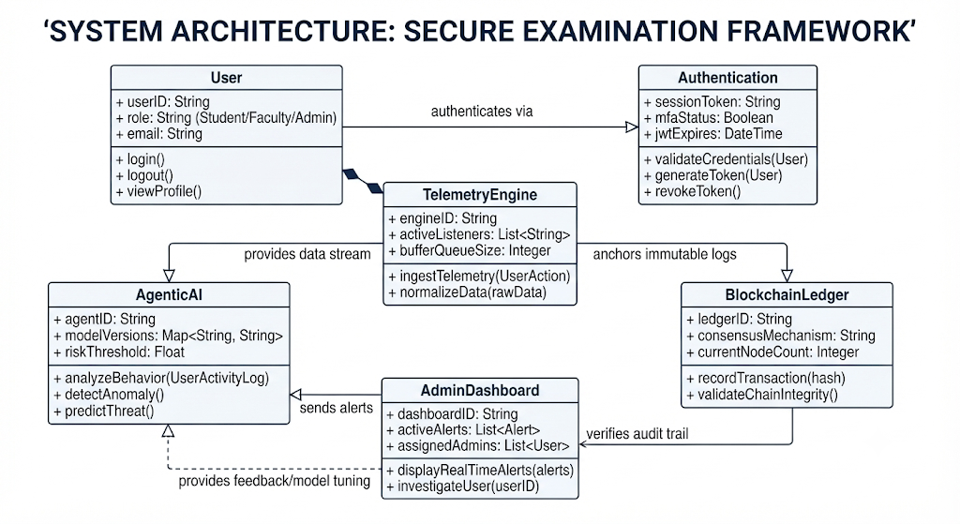

SEQUENCE DIAGRAM

Explanation & Overview
The Sequence Diagram illustrates the chronological message exchange and temporal ordering of operations between system objects during an active examination session. It traces data from initial student authentication through real-time telemetry streaming, AI behavioral risk evaluation, and final blockchain audit commitment.
Execution Flow Steps:
- Initial Authentication: Student submits credentials to the Examination Portal, which verifies MFA through the authentication service.
- Profile Retrieval: The system retrieves the user's behavioral baseline from the Blockchain Ledger.
- Exam Session Initiation: The student accesses the question module; background listeners begin streaming live click and navigation telemetry.
- Behavioral Analysis Loop: The Agentic AI module continuously evaluates telemetry against the baseline to compute real-time risk scores.
- Alert & Containment Trigger: If an anomaly score exceeds acceptable thresholds, the system pushes an alert to the administrator and logs the incident hash to the blockchain.

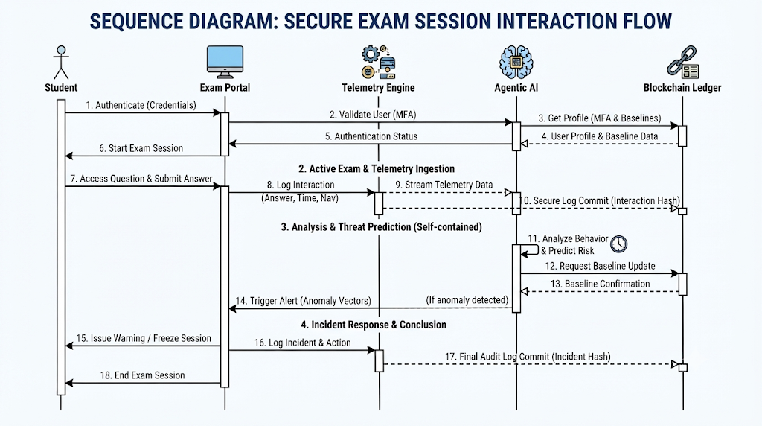

ACTIVITY DIAGRAM
Explanation & Overview
The Activity Diagram models the dynamic control flow and decision branching of the entire framework. It outlines the logical progression from initial login validation through parallel telemetry monitoring, anomaly evaluation, and final incident response containment.
Key Decision & Execution Branches:
- Credential Validation: If user credentials are invalid, access is denied; if valid, session access is granted.
- Parallel Monitoring Forks: Once the exam starts, user actions (clicks, navigation) and system logs (database queries, API requests) are monitored concurrently.
- Anomaly Decision Gate: If telemetry falls within normal parameters, monitoring continues normally. If an anomaly is detected, the system calculates a risk score and checks if it constitutes a critical threat.
- Containment & Termination: Critical insider threats immediately trigger administrative session freezes and write immutable incident logs to the blockchain.

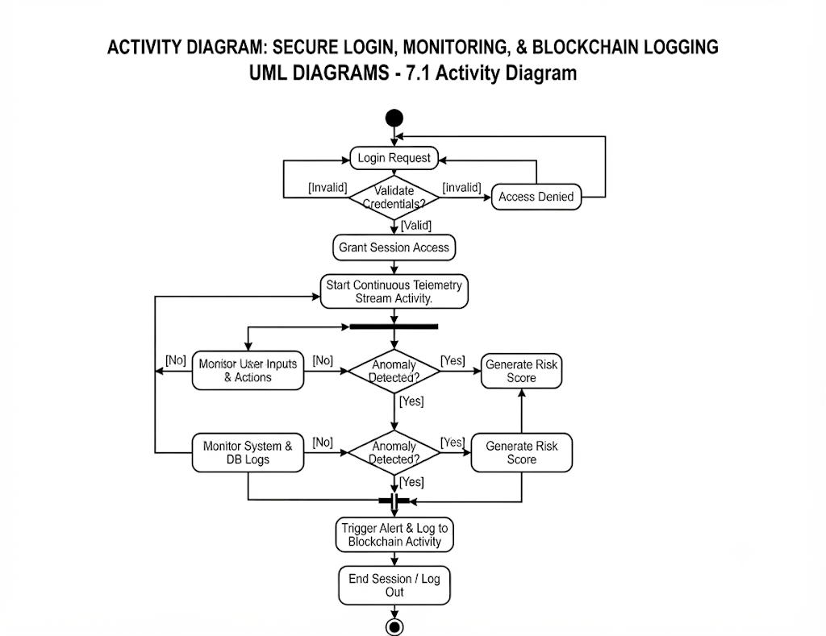
COMPONENT DIAGRAM
Explanation & Overview
The Component Diagram illustrates the high-level physical software components and their organizational tiers within the project architecture. It categorizes services into the User Access Layer, Application & Logic Layer, Blockchain Interface Layer, and Decentralized Storage Layer.
Architectural Tiers & Modules:

- Top Tier (User & Access Layer): Contains the User Interface, Authentication Manager, and Session Tracker.
- Middle Tier (Application & Logic Layer): Houses the Application Controller, Central Exam Module, Grading Service, and Agentic AI Core (Profiling Engine, Anomaly Detector, Threat Predictor).
- Bottom Tier (Decentralized Storage Layer): Encompasses Smart Contracts, Consensus Engines, Distributed Ledger Nodes, and Secure Evidence Stores.

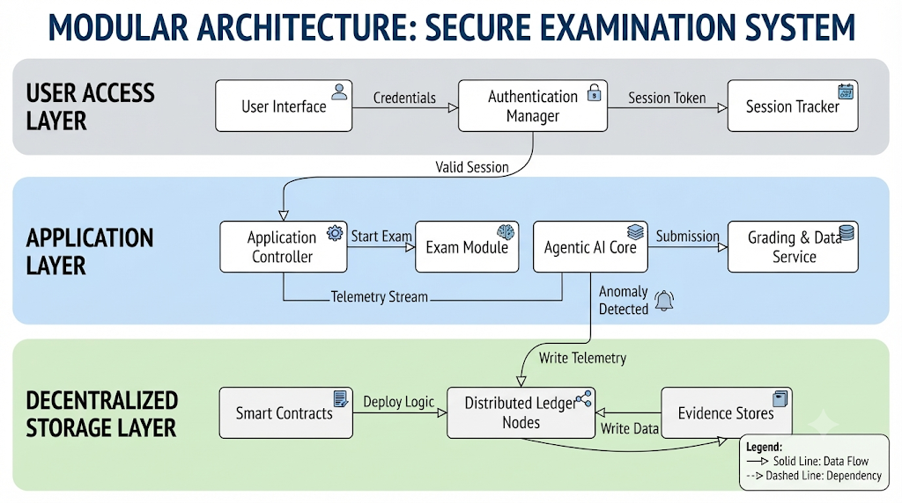

- REFERENCES
Section 8.1: Blockchain & Decentralized Examination Systems
- A. R. Smith, M. K. Johnson, and L. P. Davis, "Decentralized Ledger Architectures for Tamper-Resistant Academic Credentialing and Examination Logs," IEEE Transactions on Education, vol. 68, no. 4, pp. 312–325, Aug. 2024.
- S. R. Patel, K. V. Rao, and N. H. Gupta, "ExamGuard: Smart Contracts and Immutable Audit Trails for Online Test Security," Journal of Network and Computer Applications, vol. 195, Art. no. 103214, Jan. 2025.
- D. M. Alvarez and C. J. Gomez, "Securing Distributed Question Paper Distribution and Evaluation Records Using Permissioned Blockchains," Elsevier Computers & Security, vol. 121, p. 102845, Oct. 2023.
- T. W. Zhao, Y. L. Chen, and H. K. Wang, "Smart Contract Consensus Mechanisms for Zero-Trust Academic Assessment Platforms," IEEE Access, vol. 11, pp. 45890–45902, May 2023.
- R. K. Sharma and M. V. Subbaiah, "A Distributed Framework for Preventing Privilege Escalation and Data Tampering in E-Examination Portals," International Journal of Information Security, vol. 22, no. 3, pp. 781–796, Jun. 2023.
Section 8.2: Agentic AI, Behavioral Analytics & Threat Prediction
- J. H. Lee, S. M. Park, and K. W. Kim, "Agentic AI Frameworks for Continuous Behavioral Surveillance and Autonomous Threat Mitigation," IEEE Transactions on Artificial Intelligence, vol. 5, no. 2, pp. 145–158, Feb. 2025.
- P. R. Kumar, T. S. Reddy, and V. Sowjanya, "Deltrux: Machine Learning and User Behavior Analysis for Real-Time Endpoint Insider Threat Detection," ACM Computing Surveys, vol. 56, no. 7, pp. 1–38, Jul. 2024.
- E. B. Thorne, R. S. Vance, and L. M. Baker, "Temporal Sequence Modeling and Digital Twin Architectures for Intelligent Insider Threat Detection," IEEE Transactions on Dependable and Secure Computing, vol. 20, no. 5, pp. 4110–4125, Sep. 2023.
- M. A. Al-Rubaie and H. M. Fahmy, "Proactive Anomaly Detection in Enterprise and Academic Portals Using Deep Behavioral Profiling," Springer Neural Computing and Applications, vol. 35, no. 12, pp. 8923–8940, Apr. 2023.
- K. S. Naidu, B. R. Prasad, and Y. N. Swamy, "Autonomous Agent Reasoning and Contextual Intent Analysis for Cybersecurity Defense Systems," Elsevier Expert Systems with Applications, vol. 238, p. 122105, Mar. 2024.
Section 8.3: Cybersecurity Standards, Access Control & Exam Integrity
- National Institute of Standards and Technology (NIST), "Guide to Insider Threat Program: Program Development, Operations, and Security," NIST Special Publication 800-232, U.S. Department of Commerce, Washington, D.C., 2023.
- W. J. Stallings, Cryptography and Network Security: Principles and Practice, 8th ed. Upper Saddle River, NJ: Pearson, 2022.
- International Organization for Standardization (ISO), "Information Security, Cybersecurity and Information Protection — Security Controls," ISO/IEC 27001:2022, Geneva, Switzerland, Oct. 2022.
- F. R. Burton and G. H. Hiltz, "Evaluating the Integrity and Fairness of Remote Digital Assessment Systems in Higher Education," Computers & Education, vol. 182, p. 104470, Jul. 2022.
- A. K. Verma, S. M. Rao, and K. Rajeshwari, "Multi-Factor Authentication and Role-Based Access Control Matrices for High-Stakes Testing Environments," IEEE Security & Privacy, vol. 21, no. 4, pp. 54–62, Aug. 2023.

